Lab 17: Kernel Debugging with WinDbg (PC version)
Course Name: Malware Analysis and Reverse Engineering (IAM302)
Student Name: Nguyễn Trần Vinh – SE160258
Instructor Name: Mai Hoàng Đỉnh
Lab Due Date: 18/3/2023

Purpose
Introduction to WinDbg and kernel debugging

What You Need
- A Windows 8 machine with VMware Player installed.
- A Windows XPSP3 virtual machine to examine.

The Two Machines
You need two Windows machines to do this project: One is the TARGET machine, which is a virtual machine running Win XP SP3. The other is the WINDBG machine, which is the Windows 8 host.

Adding a Boot Menu Item to the TARGET machine
- In the Run box, execute this command:
notepad c:\boot.ini
- In Notepad, copy the existing boot line, paste it at the end of the file, and add these switches to the end of the line, as shown below:
/debug /debugport=com1 /baudrate=115200
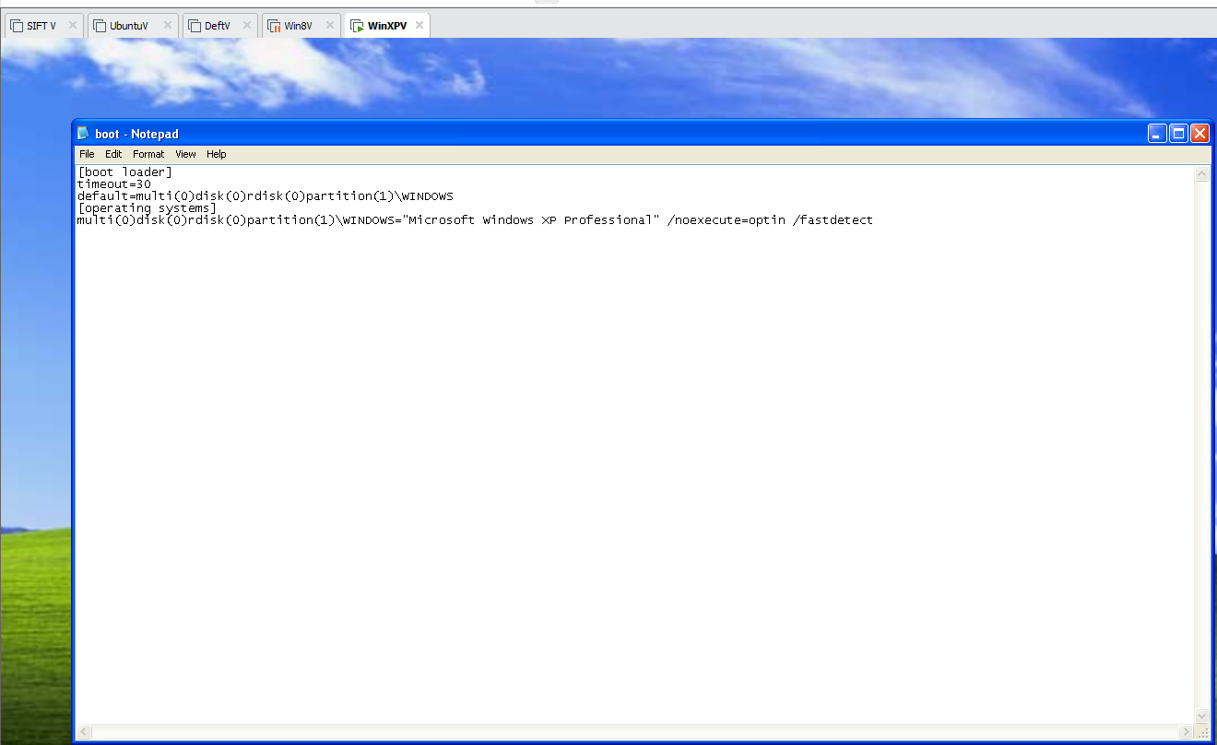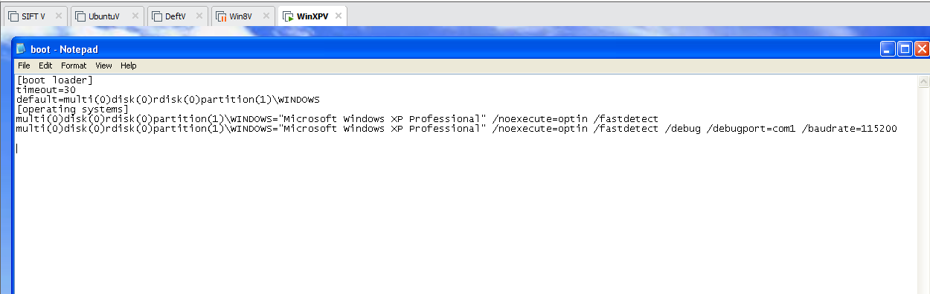

Adding a Virtual Serial Adapter
- Power off the TARGET virtual machine.
- On the WINDBG machine, start VMware Player.
- In the left pane of VMware Player, click your TARGET machine.
- At the lower right of VMware Player, click "Edit virtual machine settings".
- In the left side of the "Virtual Machine Settings" box, click the Add... button.
- In the "Hardware Type" box, select "Serial Port", as shown below.
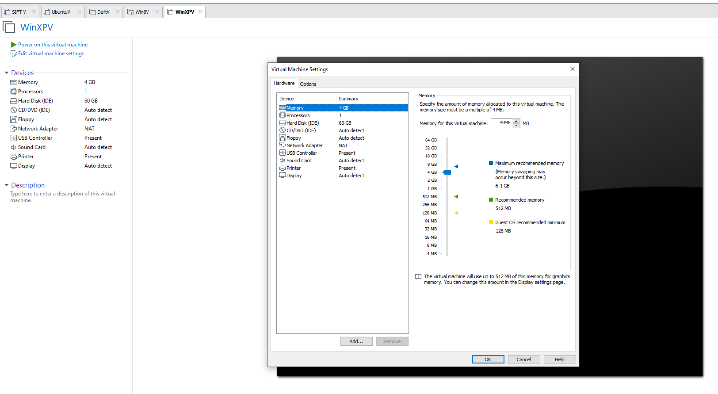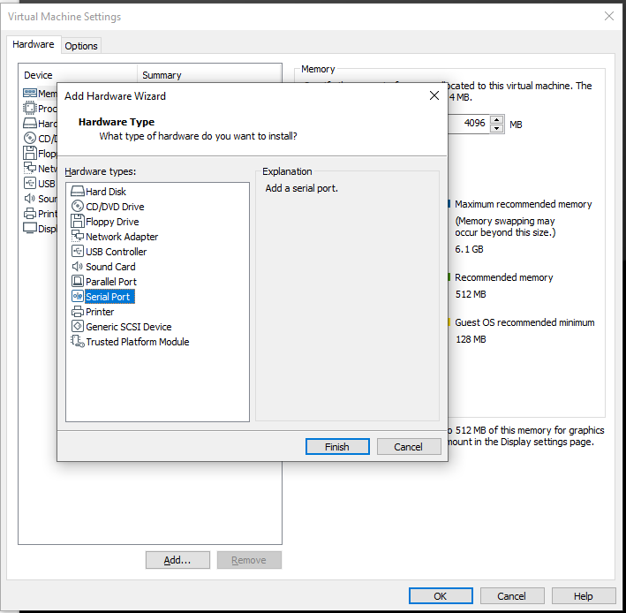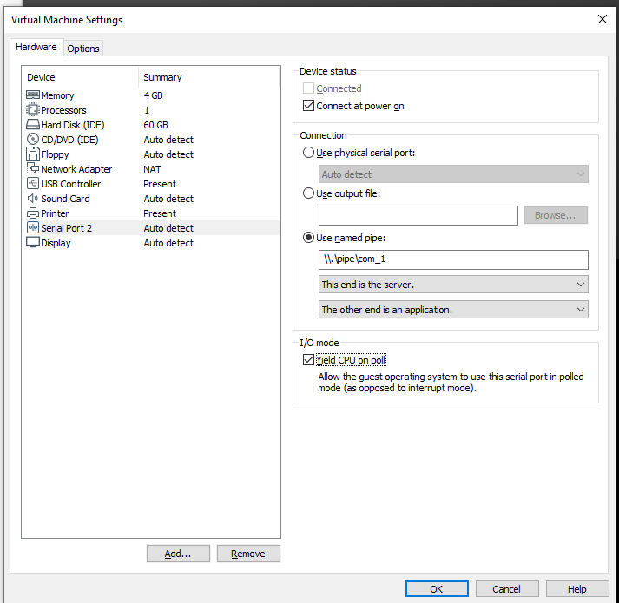

Downloading Microsoft Symbols

Installing WinDbg on the WINDBG Machine
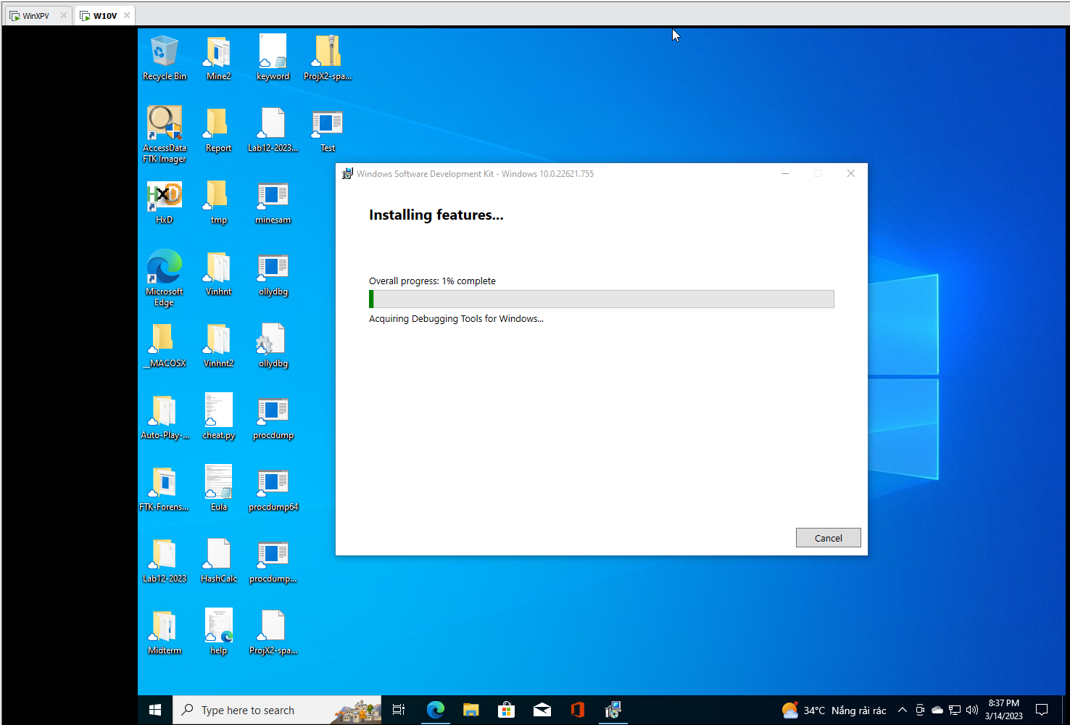
Configuring Symbols in WinDbg
